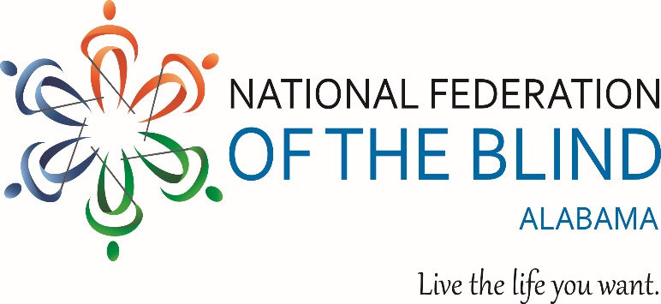

National Federation of the Blind of Alabama
2026 OPPORTUNITIES UNLIMITED Scholarship Program
Eligibility Guidelines
Deadline
The National Federation of the Blind of Alabama (NFBAL) 2026 will begin accepting applications for the 2026 Opportunities Unlimited Scholarship on November 10th, 2025. All Applications must be submitted no later than February 28th 2026, by 11:59 PM
About the Scholarship
Unlock your potential with the Opportunities Unlimited Scholarship, specifically designed for non-traditional blind students ready to forge new career paths. This unique scholarship provides financial support and mentorship for individuals pursuing short-term vocational training programs in fields such as massage therapy, cosmetology, culinary arts, and more.
Whether you’re upgrading your skills or making a career change, this scholarship supports programs ranging from 6-36 months in duration. Join a vibrant network of trailblazers and take the next step toward achieving your goals
Apply now and turn your aspirations into reality!

Eligibility Requirements
To be considered for the 2026 Opportunities Unlimited Scholarship Applicants must meet the following criteria.
- Be legally blind in both eyes.
- Reside in Alabama or plan to attend a vocational training program in Alabama during 2026
- Be enrolled in or planning to enroll in a vocational trade or technical training program in 2026
- Attend the full NFBAL State Convention held in Montgomery AL April 17-19 2026.

Scholarship recipients will receive financial assistance to attend the state convention The event will feature student focused programing, networking opportunities, resources on blindness, and a banquet where scholarship awards will be presented.

Questions? Contact: Scholarship Chair: Grace Anderson
Phone: 423-827-5628
Email: nfbal.scholarships@gmail.com

