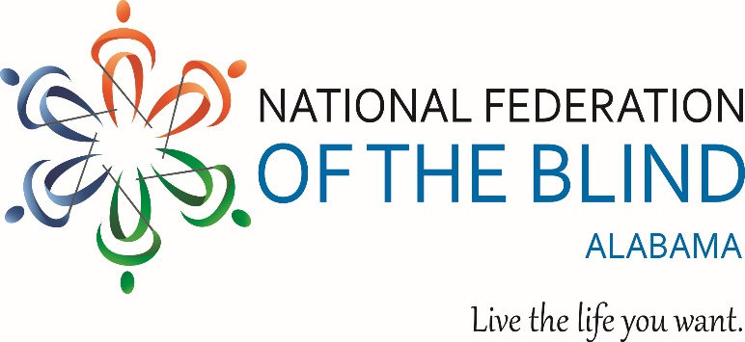

National Federation of the Blind of Alabama
2026 Reverend Frank Lee Memorial Scholarship Program
Eligibility Guidelines
Deadline
The National Federation of the Blind of Alabama (NFBA) 2026 Scholarship Program will begin accepting applications on November 10th, 2025, and the deadline to submit an application is February 13th, 2026, by 11:59 PM
What
To recognize achievement by blind scholars, the National Federation of the Blind of Alabama annually offers blind college students currently residing in the state of Alabama or attending or planning to attend a college in Alabama the opportunity to win a merit-based state level scholarship. The scholarships are based on academic excellence, community service, and leadership.
Eligibility
Students absolutely must:
- Be legally blind in both eyes.
- Be currently residing in Alabama or plan to attend a college/institution in Alabama
- Be pursuing or planning to pursue a full-time post-secondary course of study in a degree program at an accredited institution in the fall of 2026.
- Participate in the entire convention being held in Montgomery AL, April 17th-19th, 2026. In addition to the scholarship, winners will receive assistance to attend the NFBAL state convention where there will be student related activities, networking opportunities, valuable information on blindness, a banquet in which the winner will be presented with their scholarship, and much more.

Questions? Contact: Scholarship Chair: Grace Anderson
Phone: 423-827-5628
Email: nfbal.scholarships@gmail.com

