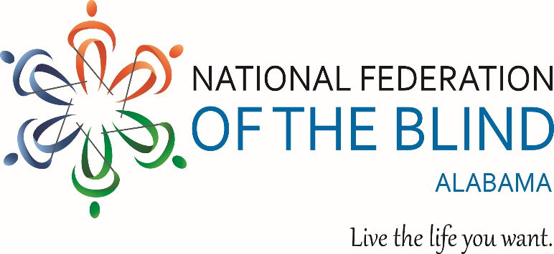

NFBAL 2026 Opportunities Unlimited Scholarship APPLICATION FORM

- Deadline: This completed application form and all required supporting documents must be received no later than February 13th 2026 at 11:59PM.
- Notification: Scholarship recipients will be notified by March 17th, 2026
- Requirements: You must meet all eligibility criteria outlined in the NFB of Alabama Eligibility Guidelines and scholarship checklist documents, which are provided separately. Applications will not be considered unless all required materials are submitted.
- Completion: Please complete each section of this application if a section does not apply to you, write Non-Applicable (N/A. You may attach additional pages if more space is needed for complete responses.
Personal Information
Full Name:
Home address: (Applicants must be a resident of Alabama or attending or planning to attend a college in Alabama in the fall of 2026).
Street Address: Apt:
City: State: Zip:
Primary Phone Number:
Secondary Phone Number:
Email address:
Date of birth:
Have you won an NFB of Alabama scholarship before?
If Yes, Please indicate the year awarded.
Educational Information
Training Program to be attended in 2026
If undecided list all program under consideration. Note: (Alabama Residents are not required to attend a program within the state) being attended in 2026 (if undecided list all programs under consideration. If a resident of Alabama, applicants do not have to attend a training program in Alabama).
List of Previously Attended Programs or Institutions
Vocational Goal:
High School Information:
High school from which you graduated or will graduate?
Name:
City State:
Cumulative GPA:
SAT and/or ACT scores “High school seniors only” (Please provide documentation):
Achievements and Involvement
Honors & Awards
Please list any honors or awards that are relevant to your vocational goals.
Community Service
High School Seniors and recent graduates, list all community service activities since the beginning of high school.
Other applicants: List all community service activities since high school
Extra-Curricular Activities
Include all current involvement in student organizations, clubs leadership roles etc.
Employment History
Include any type of paid or volunteer work experience
Submission Instructions
Please submit your completed application and all required supporting documents to
Scholarship Chair:

Grace Anderson
Phone: (423)827-5628
Email: nfbal.scholarships@gmail.com
Mailing Address:116 Deer Chase Drive Chelsea AL, 35043

Reminders

- Incomplete applications will not be considered
- Ensure you review and comply with the Scholarship Eligibility Guidelines and the checklist document before submitting.
- Use N/A for any section that is not applicable to your circumstances

