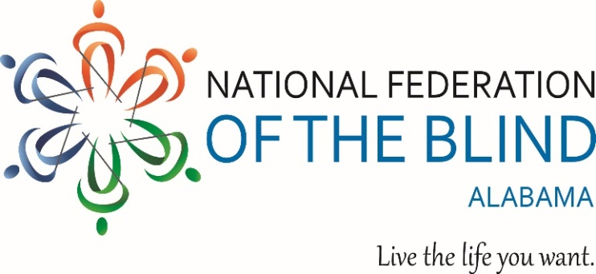
2026 OPPORTUNITIES UNLIMITED SCHOLARSHIP Application Submission Checklist
To be considered for the 2026 Opportunities Unlimited Scholarship applicants must submit a complete application package by 11:59PM on February 28th 2026. A complete submission includes the scholarship application form, all required documents listed below, and an interview request.
DEADLINE February 28th 2026 by 11:59PM
Questions? Call 423-827-5628
Submission Methods:
- Email: Nfbal.scholarships@gmail.com
- Mail: 116 Deer Chase Drive Chelsea AL, 35043
- Submission must be emailed or postmarked by the deadline
ACCEPTED FILE FORMATS
FILE FORMATS: Documents submitted via attachment to an email must be in DOC, DOCX, RTF, or PDF file format.
Faxed documents will not be accepted.
REQUIRED MATERIALS CHECKLIST
[ ] Completed 2026 Scholarship Application Form. Submit via email or printed copy all no applicable sections should be marked N/A
[ ] Personal Essay 500 word limit
Topic: You help the committee understand what sets you apart
Consider the following prompts.
Who are you?
What are your outstanding qualities?
How do you navigate life as a blind individual?
What makes you unique and deserving of this scholarship?
We recommend using Arial, 12 point font and having someone proofread your essay before submission.
[ ] At Least One Letter of Recommendation:
You may send more than one letter. Letters can be:
- Sent directly to us by the recommender, or
- Included as an attachment with your application with the recommenders permission.
[ ] Transcript(s)/ or Proof of Enrollment
Provide a transcript or proof of enrollment from your current or intended training program
If enrolled for less than one year, include your high school transcript (original or copy)
We accept documents from the institution, a forwarding service or directly from you.
[ ] Proof of Legal Blindness:
Submit a signed statement on official letterhead from a qualified professional confirming you are legally blind in both eyes under the federal definition.
Acceptable certifying authorities include:
- Optician, Optometrist, Ophthalmologist, or physician
- Rehabilitation Counselor
- Itinerant teacher or other blindness related professionals
Note: Do not submit full medical records.
[ ] Interview Request
Applicants must contact Grace Anderson, Scholarship Committee Chair, to request an interview before February 28th.
Interviews will be scheduled between February 28th and March 2nd. Applicants will be contacted in advance with interview details.

