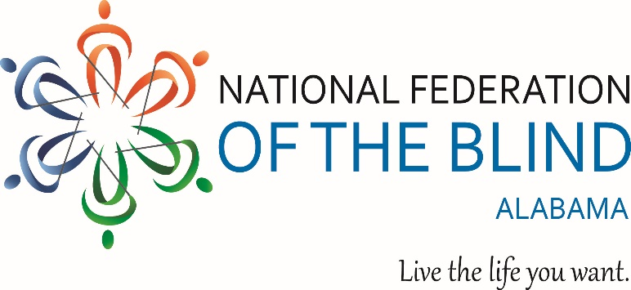

National Federation of the Blind of Alabama
2022 Reverend Frank Lee Memorial Scholarship Program
Eligibility Guidelines
Deadline
The National Federation of the Blind of Alabama (NFBA) 2022 Scholarship program will begin accepting applications on November 1st 2021 and the deadline to submit an application is January 14, 2022, by 11:59 PM
What
To recognize achievement by blind scholars, the National Federation of the Blind of Alabama annually offers four blind college students currently residing in the state of Alabama the opportunity to win a merit-based state level scholarship in the amount of one $1,500.00 scholarship one $1,000.00 scholarship and two $500.00 scholarships. The scholarships are based on academic excellence, community service, and leadership.
Eligibility
Students absolutely must:
- Be legally blind in both eyes.
- Be currently residing in Alabama
- Be pursuing or planning to pursue a full-time post-secondary course of study in a degree program at an accredited institution in the fall of 2022.
- Participate in the entire convention being held in Birmingham AL, March 4- 6, 2022. In addition to the scholarship, winners will receive assistance to attend the NFBA state convention where there will be student related activities, networking opportunities, valuable information on blindness, a banquet in which the winners will be presented with their scholarship, and much more.

Questions? Contact: Scholarship Chair: Grace Anderson
Phone: 423-827-5628
Email: nfbal.scholarships@gmail.com

