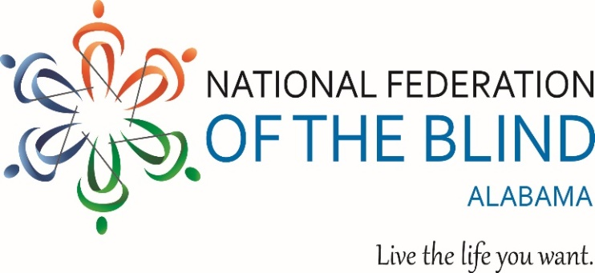
2022 REVEREND FRANK LEE MEMORIAL SCHOLARSHIP Submission Checklist
A complete application submitted before the deadline consists of the 2022 Scholarship Application Form, the required documents listed below, and one interview request.
DEADLINE: January 14 2022, 11:59 P.M. (email date or postmarked mail to nfbal.schoarships@gmail.com or 116 Deer Chase Drive Chelsea AL, 35043). Questions? Call 423-827-5628
FILE FORMATS: Documents submitted via attachment to an email must be in DOC, DOCX, RTF, or PDF file format. (We do not accept faxed documents.)
REQUIRMENTS:
[ ] One completed 2022 Scholarship Application Form, email or in print Non-applicable questions should be marked N/A.
[ ] One essay, limited to 500 words: The topic is you. The committee members want to know what sets you apart from other applicants. Who are you? What are your outstanding qualities? How do you handle your blindness? What makes you unique and qualifies you for a scholarship? We recommend using Arial 12-point font and having someone proofread your essay before you submit it.
[ ] At least one letter of recommendation: You may send more than one letter if you wish. The author may send his/her letter directly to us via email or, if the author permits, you may attach it to the application form
[ ] Transcript(s): Provide a transcript (original or copy) from the institution you are currently attending and from all other postsecondary institutions you’ve attended. If you have attended less than one year of higher education, provide your high school transcript. We accept transcripts sent by your institution, by a forwarding service, or by you.
[ ] High school seniors only—Report(s) on college entrance examinations should be submitted, if available: Send a copy of your report summary from the ACT, SAT, or other such standardized tests.
[ ] Proof of Legal Blindness: Do not send actual medical records. Provide a clear statement from a qualified professional that certifies you are "legally blind" in both eyes according to the federal definition. This must be a signed statement on business/agency letterhead.
Certifying Authority: The statement must be completed by a trained certifying authority, such as an optician, optometrist, ophthalmologist, physician; rehabilitation counselor, itinerant teacher, or other professional in work with the blind.
[ ] Scholarship Committee’s Interview: Before the deadline of January
14, applicants must request an interview from Grace Anderson Scholarship Chairwoman. Applicants must be available for an interview between January 24th and January 29th. Applicants will be contacted prior to the 24th to receive more specific interview details.

